OET Writing Sub-test Skill 2: Summarising Information

Objectives

- Identify OET Writing Assessment Criteria which relate to summarising.
- Combine key facts from case notes in order to create a concise accurate complex sentence.

Questions | Answers
What are some common scenarios from your workplace when you have to produce written summaries from more detailed information? | Patient reporting - providing a picture (family history, social history, medical concerns)  Progress note -  Incident report  Surgical summaries
What are some key issues which impact this skill? | Time

Test Taking Strategy: Identify what to leave out and keep in

Read the following case notes and answer these questions:

- Who is the recipient of the letter?
- What are the health circumstances of the patient?
- Why is the letter being written?

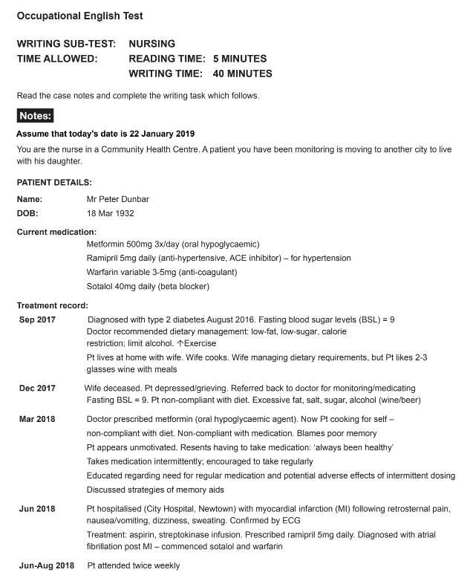

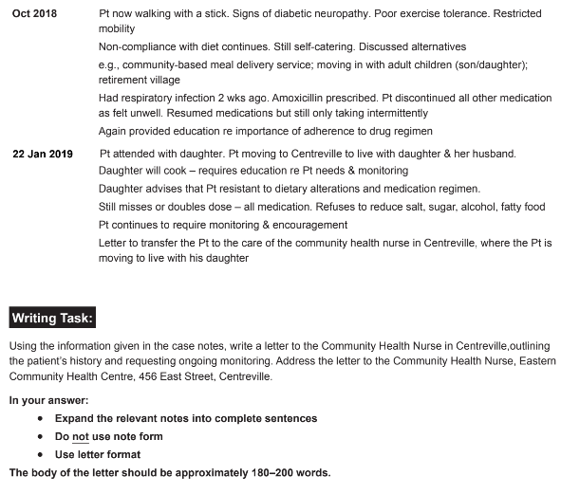

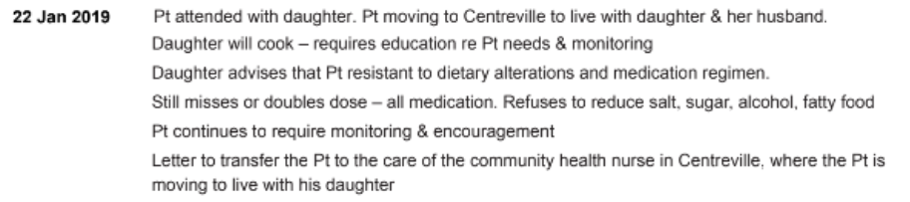

Questions | Answers
Which facts are relevant to the reader and which can be omitted? Why?

Which facts/figures can’t be paraphrased without changing the meaning?

Writing Summarising Sentences

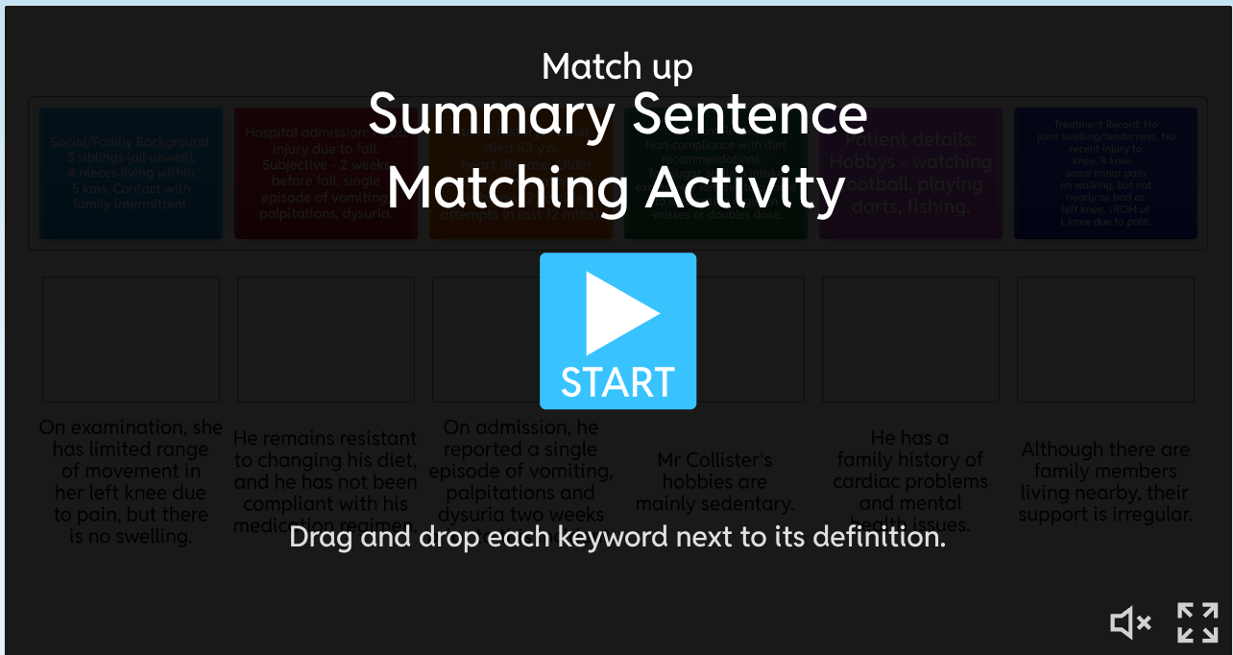

- Which information is omitted? Why?
- Which information is paraphrased? Is the meaning still clear and accurate?
- Underline words which are left unchanged. Why?

