OET Reading Skill 5: Understanding How Writers Develop Meaning

Objectives

- Identify at least two examples of how a writer develops meaning in a discursive text
- Explain the writer’s purpose in including a fact/statistic/opinion/patient experience/study in a paragraph.

Examples | Suggested answers for how they differ, and which types of texts they are typically found in
Research Study | Medical Journals  Articles  Clinical Guidelines which includes latest research
Fact | Clinical guidelines  Encyclopedias  Continued Professional Development readings  Articles  Steps/ Guides
Statistic | Research Report
Patient Experience | Reports  Case studies  Surveys
Expert Opinion | Medical Journals  Report

Using Genre Features for a Purpose

Read the following quote:

“Mild forgetfulness like forgetting an appointment, why you entered a room or where you kept your keys are considered a normal part of aging. However, some experts say it can be a symptom of mild cognitive impairment, a precursor of Alzheimer’s.”

Now, think of one thing from the previous activity that supports the quote, then one thing that contradicts or disproves the quote.

To support the statement | Quote | To disprove the statement
Study - looking into healthcare workers’ experiences working with people who have Alzheimer’s. | “Mild forgetfulness like  forgetting an appointment, why you entered a room or where you kept your keys are considered a normal part of aging. However, some experts say it can be a symptom of mild cognitive impairment, a precursor of Alzheimer’s.”  (Source: Medical News Today) | Research Study - into presentation, prognosis, and to establish a difference.
Statistics |  | Looking at the demographic for the research.

Questions | Answers
Where would you find this kind of statement? | Research studies  Shared experience  Medical Journal
What makes this statement different from the kind of reading you do every day at work? | We read more facts that have already been researched, rather than experience.
How often do you do this kind of reading? | Information changes regularly so keeping up is important to offer the best care.

Feature Analysis Table

“Dr. Lauren Bennett, a clinical neuropsychologist at Hoag’s Pickup Family Neurosciences Institute in the Los Angeles area, who was not involved in the study, told Medical News Today it’s usually other people who first notice a person’s minor cognitive impairment. “On average, family members notice the first symptoms of cognitive change two years before the first health professional consultation regarding the cognitive decline,” Bennett said. “This statistic highlights the importance of regular cognitive screening for older adults and seeking input from loved ones whenever possible.” Bennett said people who believe they may have MCI should invite loved ones to share feedback with care providers if they note any declines
in cognitive functioning. “Seek out annual cognitive screening from the age of 55 on (and) talk openly with your primary care provider about any cognitive concerns and request regular cognitive assessments,” Bennett said.”

(Source: Medical News Today)

1. Identify whether the writer has used these features to develop meaning.
2. If yes, give an example from the text.
3. Explain why the writer has used this feature.

Genre Feature | Has the writer used this feature to develop meaning? Yes/No? | Example in text | Why has the writer used this feature?
Study
Fact
Statistic | Yes | On average, family members notice the first symptoms of cognitive change two years before the first health professional consultation | Call for more research?  To pertain additional facts.
Patient experience | Yes - carer/ patient experience | “On average, family members notice the first symptoms of cognitive change two years before the first health professional consultation regarding the cognitive decline,”  it’s usually other people who first notice a person’s minor cognitive impairment. | Regular interaction with people who are MCI/ decline.
Expert opinion | Yes

Do the features support or contradict?

People with MCI often go undiagnosed and don’t realise they have it.
“Since it’s considered normal by many – including some doctors – people who have MCI don’t always know it and miss out on taking preventative measures or getting treated, according to two new studies published in parallel by researchers at the USC Dornsife College of Letters, Arts and Sciences in Los Angeles.
In one study, researchers looked at data from 40 million Medicare beneficiaries, 65 years and older, and compared the proportion diagnosed with MCI with the rate expected in this age group. They reported that fewer than 8% of expected cases were actually diagnosed.
That means that of the 8 million individuals predicted to have MCI based on their demographic profile – which includes age and gender – more than 7 million went undiagnosed.”

Task:
Identify and underline all the instances of fact / statistic / study / expert opinion / patient experience.
• Discuss if each instance identified supports or contradicts the main point of the paragraph.

Freer Practice
- Answer the following Part C questions using the skill we have covered in today’s lesson.
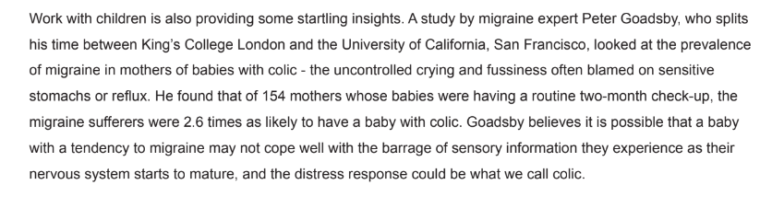
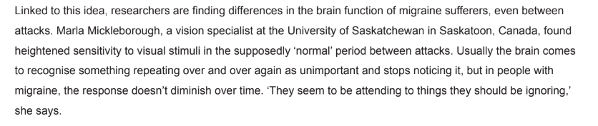

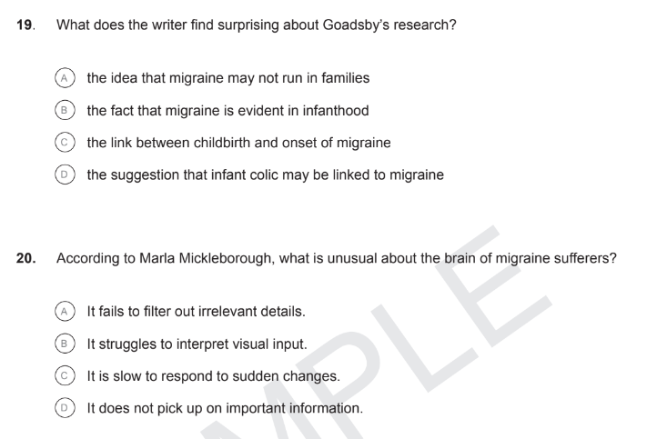

Homework
Complete Reading Sub-test Practice 2: Part A, B & C.

