OET Reading Skill 4 - Developing Question Comprehension

Objectives

- Rephrase a question in your own words.

Questions | Answers
What difficulties do you have when trying to understand questions in a test? (Any test, not specifically OET) | When you don’t understand a key word(s) in the question.  Type of question  Lack a clue
Do any of these apply to the OET Reading sub-test? | Not knowing the key word (e.g. chaperone)

How to Rephrase Questions: Dos and Don’ts
What does ‘rephrase the question’ mean?
Using different words to understand the question in your own way.

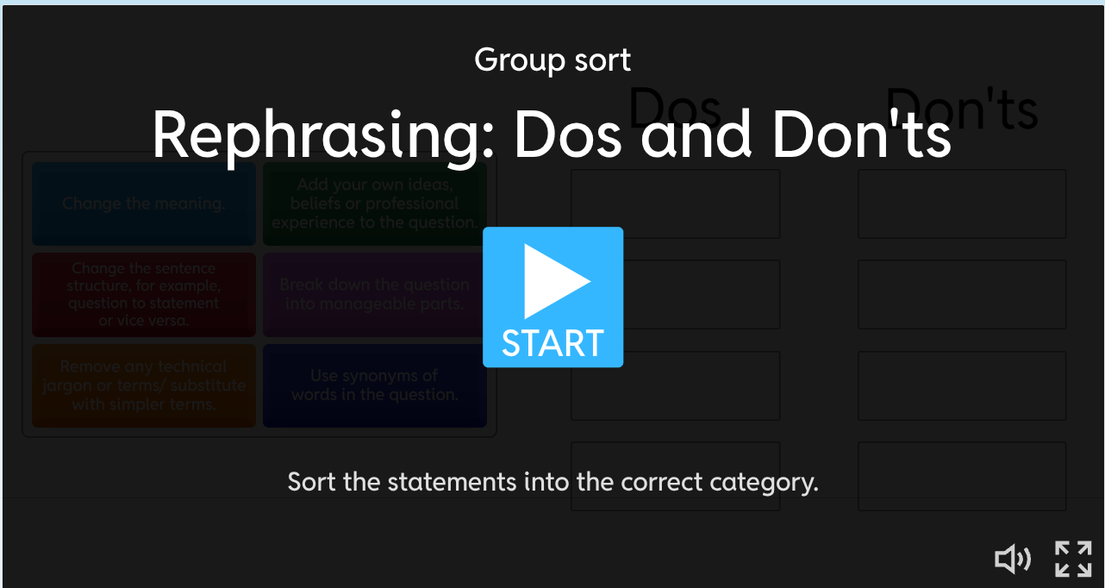
Looking at How to Rephrase Questions: Techniques

Questioning Techniques
Change the sentence structure,  for example, question to statement or vice versa | Use synonyms  of words in the question. | Breakdown the question into manageable parts. | Remove any technical jargon or terms/substitute with simpler terms

Test Question | Rephrased as | Technique(s) used (1, 2, 3, 4)
A. What procedure necessitates the ingestion of a contrast agent? | What procedure do you need to drink a special liquid for? | 4
B. The medication makes patients feel... | How does the medication make patients feel? | 1
C. How do anatomical structures involved in the auditory pathway process sound signals? | Explain the parts of the ear and brain that help us hear and understand sounds. | 1, 2, 4
D. What is the main point of the policy guidelines on waste disposal on the ward? | The guidelines are about waste disposal on the ward.  The primary focus of the guidelines is... | 1, 3

Guided Practice

Original Reading sub-test question | Rephrasing technique used | Rephrased question
What analgesic should be given to a patient who is allergic to morphine? | 2,4 | What drug should be given to a person who has reacted to morphine?
What must all staff involved in the transfusion process do? | 1 | Staff involved in the transfusion process must…
In the final paragraph, the quote from Van Cauter is used to suggest that… | 1 | What does Van Cauter’s quote suggest in the final paragraph?
The writer regards the study of children in foster care as significant because it… | 1, 2 | Why does the writer think the study of children in foster care is important?
In the final paragraph, what does the writer imply about addiction to ADHD medication? | 1, 2 | The writer suggests that the addiction to ADHD medication is…

Freer Practice

Answer the following Part B questions using the question rephrasing techniques.

After this, we will share the rephrased versions and techniques you used.

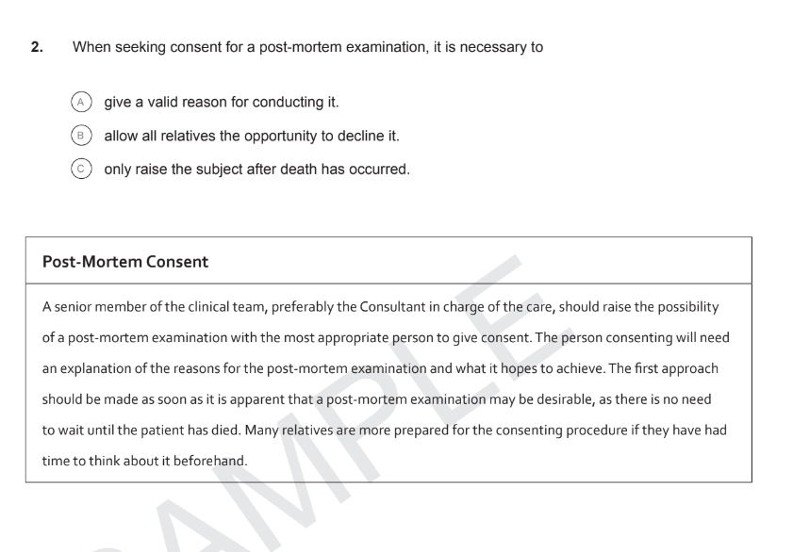
What are the requirements if you want to seek permission for a post-mortem examination?

What do you need if you want permission for a post-mortem?

It is required, when one is seeking consent for a post-mortem examination, that one should…

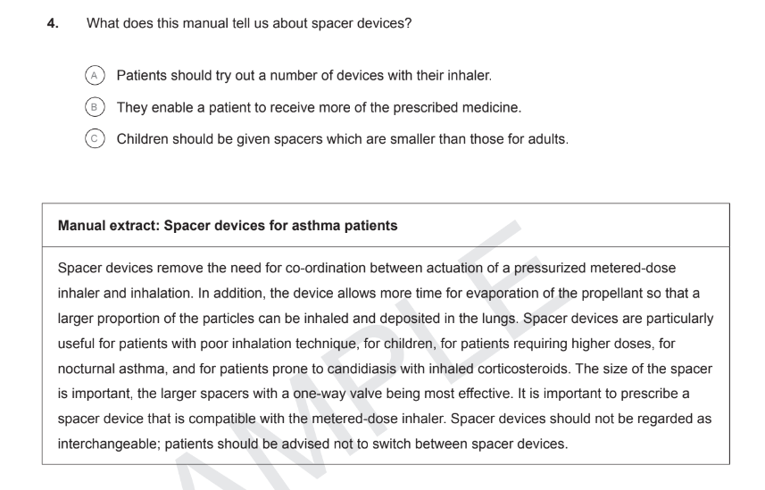

(Answers: Sample Test 3)

