OET Reading Skill 3 - Understanding Text Types

Objectives

- Identify the purpose, content and structure of guidelines.
- Recognise the course of action contained in guidelines.

Activating Prior Knowledge

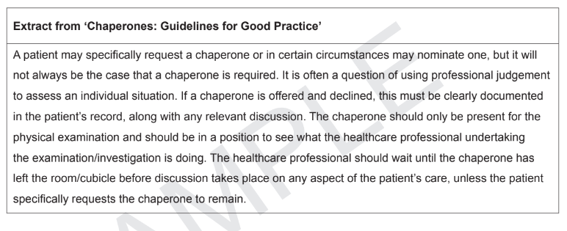

Questions | Suggested answers
Who are the intended readers? | Healthcare worker - student nurse
What topics do they cover? | Chaperones (main)  Professional judgement (When a chaperone might be required)  What chaperones are required to do
What kind of information do you find in them?
How are they structured, i.e., how do you find the information you are looking for in them?
What would you do after you read a guideline?

Using a Graphic Organiser

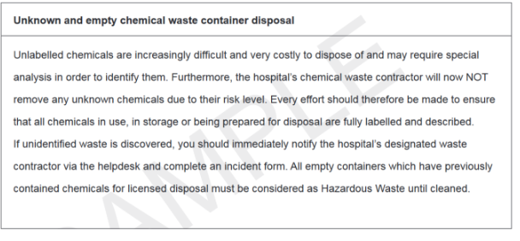

If you were a member of staff reading this guideline, what’s the main thing you would start doing after reading it?

Topic  (heading/sub-heading)  What is the guideline about?  Chemical waste disposal  (unknown and empty  containers) | Where  Hospital | Actions  (stop/ start/ continue)  Stop  disposal of unknown  chemicals  Start  • Labelling/ describing all  chemicals in use  • Notify contractor via  Helpdesk/incident form if  unidentified waste discovered  • Consider empty containers  that contained chemicals  Hazardous Waste  Continue  NA
When
When disposing chemicals in storage or those being prepared for disposal

How
Should be labelled and described

Why
Risk level is high. Unlabelled chemicals difficult and costly
to identify for disposal.

Reading Practice: Using a Graphic Organiser

Topic  (heading/sub-heading)  What is the guideline about?  Providing information about good practice for chaperones | Where  Hospital  Clinic  Nursing Home | Actions  (stop/ start/ continue)  Stop  Discussing patient care in front of the chaperone unless requested by the patient.  Start  Confidentiality  Respecting patient opinions (if they decline a chaperone), document if they decline.  Being present during the physical examination only.  Continue  Confidentiality
When
Considering the need for a chaperone

How
Situation/ Patient Condition

Professional Judgement

Why

To ensure their comfort and preserve dignity.
Neutral environment during intimate or physical examinations.

Reading Practice: Looking at a test question



Possible Answers - How do they match up with your suggestions?

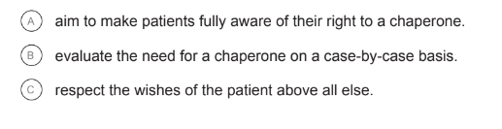

Graphic Organiser Feedback

Discuss your experience using the graphic organiser for Part B of the reading sub-test.

