OET Reading Skill 2 - Ambiguity Tolerance

Objectives

- List and recognise a number of different context clues to use when reading unfamiliar content.
- Use context clues to arrive at approximations of meaning of unfamiliar vocabulary while reading.

Questions | Answers
What happens when you encounter an  unknown word when reading in your first language? | Keep calm!  Continue reading, perhaps for further context and information about the sentence as a whole.  Digest it - continue with the paragraph. Gather information.
What do you do when you encounter a  word you’ve never seen before when  reading in English? | Dictionaries

Focus on Context Clues 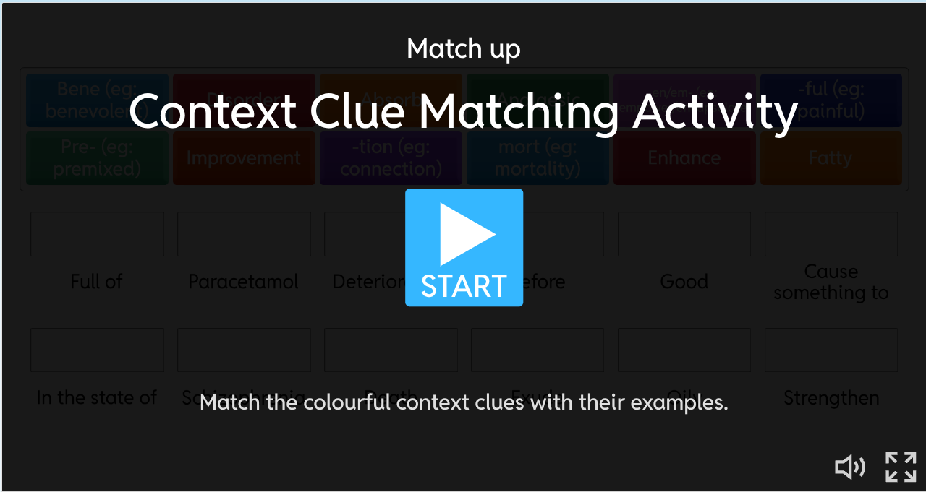
Categorising Context Clues

Categories | Pairs of Context Clues and Examples
Root Words
the basic part of a word
Prefixes
A group of letters added to the beginning of a base word to change its meaning
Suffixes
A group of letters added to the end of a base word to change its meaning
Synonyms
A word or phrase that has the same meaning as another word/ phrase
Hyponyms
A word or phrase with a meaning that is part of a broader category.
Antonyms
A word that is the exact opposite of another word

Fill in the gaps | Options
Embracing a balanced diet and regular exercise can  lead to improved well-being, while neglecting these  vital aspects of self-care often results in a deterioration of health and an increased risk of chronic diseases. | Strengthen  Disorders  Deterioration
Medical advancements continue to enhance patient  outcomes, while ongoing research seeks to strengthen the overall quality of healthcare delivery. | Strengthen  Disorders  Deterioration
Disorders, such as schizophrenia and PTSD, are often treated with psychological intervention and medication. | Strengthen  Disorders  Deterioration

Guided Reading Skills Practice

Memo
To: All Staff
Re: Withdrawal of seerful sispion
Seerful sispion preparations will shortly be withdrawn due to limited availability of the active ingredient.
As people with sispion-treated diabetes who currently use seerful sispion preparations will continue to require sispion treatment, they will need to be changed to alternative, acceptable preparations.

Questions | Answers
What do you think ‘seerful sispion’ is? | Metformin  Insulin
What part of speech are these two nonsense words? | Noun - Medicine  Adjective - Seerful (describing the noun sispion)
What are the clues that helped you guess what these words mean?

Memo
To: All Staff
Re: Withdrawal of seerful insulin
Seerful insulin preparations will shortly be withdrawn due to limited availability of the active ingredient.
As people with insulin-treated diabetes who currently use seerful insulin preparations will continue to require insulin treatment, they will need to be changed to alternative, acceptable preparations.

Questions | Answers
What does this memo tell medical professionals about ‘seerful’ insulin?
Is it necessary to understand the word ‘seerful’ to answer it?

(Sample test 2)

Medicine Cupboard Keys

The fips for the controlled drug cupboard are the responsibility of the nurse in charge. They may be passed to a registered nurse in order for them to carry out their duties and returned to the nurse in charge. If the fips for the controlled drug cupboard go missing, the locks must be changed and pharmacy informed and an incident form completed. The controlled drug cupboard fips should be kept separately from the main body of fips. Apart from in exceptional circumstances, the fips should not leave the ward or department. If necessary, the nurse in charge should arrange for the fips to be held in a neighbouring ward or department by the nurse in charge.

