UG to UK Healthcare - Group 9

Reading Skill 1 - Using Textual Features
Yolanda

Elvis

Objectives:

- List common textual features used to organise information in reference texts
- Use textual features to more efficiently identify text contents and locate specific information.

Questions | Suggested Answers
Imagine a 60-year-old patient with a foot ulcer has presented for treatment.

Your job is to provide care and the first step is to assess the foot for treatment.

What kind of reference text would you use to perform this task?
What are some other kinds of similar reference texts that you read at work for other situations? | Treatment pathways  Medication information  Dosage charts

Workplace Reading Habits - Questionnaire
Questions | Answer options
1. When do you usually need to read reference texts? | - When completing a task involving a patient/colleague.  - When I'm back in the comfort of my home.
2. How do you decide where to look for information you need? | - I look at every reference text available to decide.  - I look at the one most likely to contain the information I need.
3. At work, how much time do you have to find something you're looking for in these texts? | - A few seconds  - 1-2 minutes  - 10-20 minutes  - More than 20 minutes
4. How do your eyes move as you read reference texts? | - Left to right  - From start to finish  - In different directions on the page
5. What do you look at first? | - I look at charts/tables.  - I read the title and think about the contents.  - It changes every time.
6. Do you get distracted by unknown vocabulary? | - Yes  - No

- Skimming is an effective skill to help pay attention to:
  - Headings
  - Sub-headings
  - Labels
  - First sentences of paragraphs
  - Content words

Identifying Textual Features
Which textual features of the texts below make them easy to read?
Bold
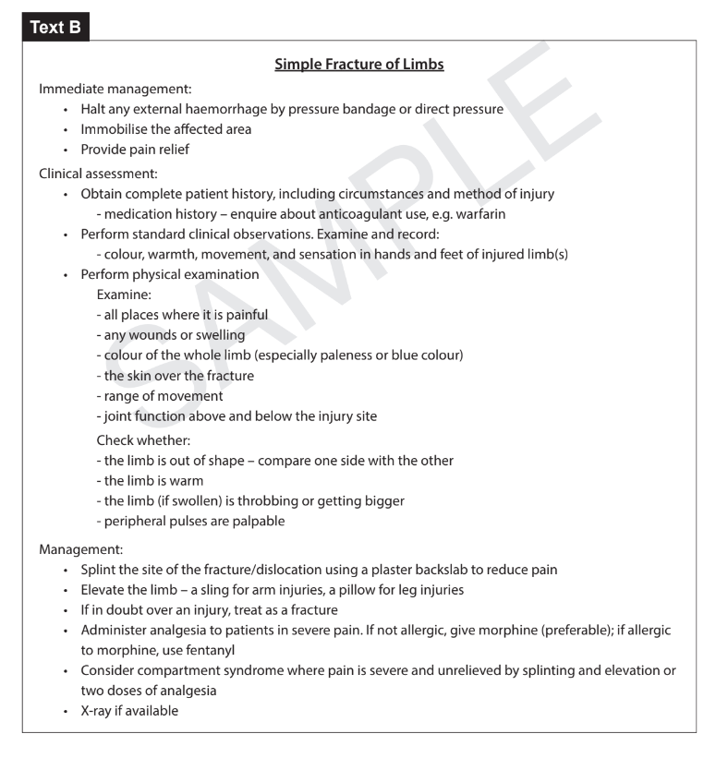
Heading in bold
Different paragraphs (sub-headings)
Bullet Points

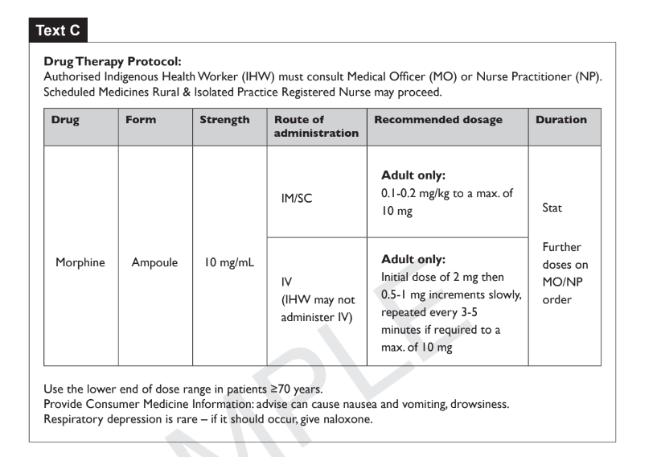
Titles
Table - sub-titles within table highlighting fields
Footnotes

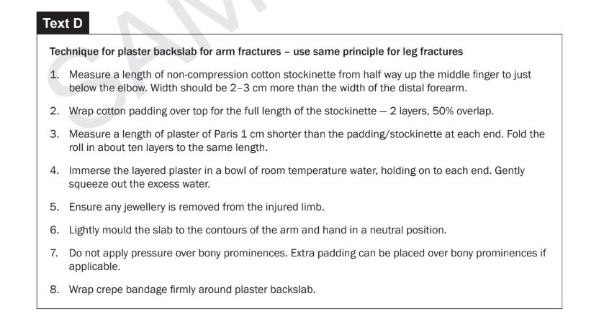
Title
Numbering - what comes first, guide in order

Reading Skills Practice

Using only the provided textual features, your task is to anticipate what kind of information you would expect to find in these texts.

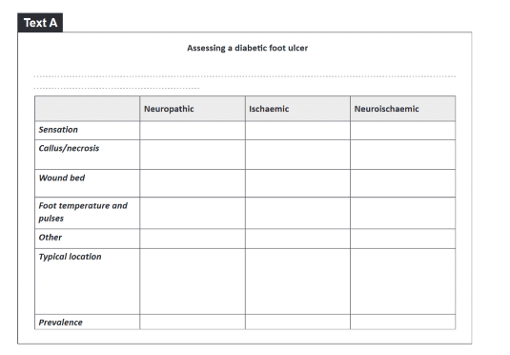
Descriptions about assessment

Guide on how the ulcer is supposed to be handled.
Possible methods and what to avoid and what to consider.
Instructions.

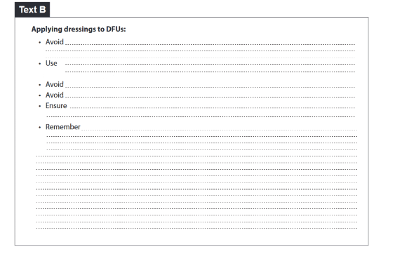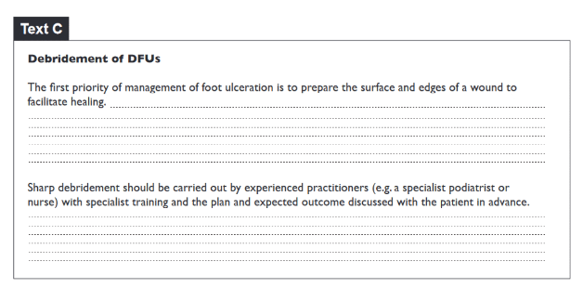
What to do first. Who is supposed to carry out the procedure/ how to assist.
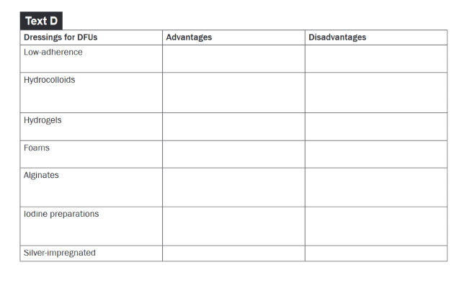
Different classes of dressings, with advantages and disadvantages.

Now, have a go at answering questions 1-6 based on the anticipated information you have:

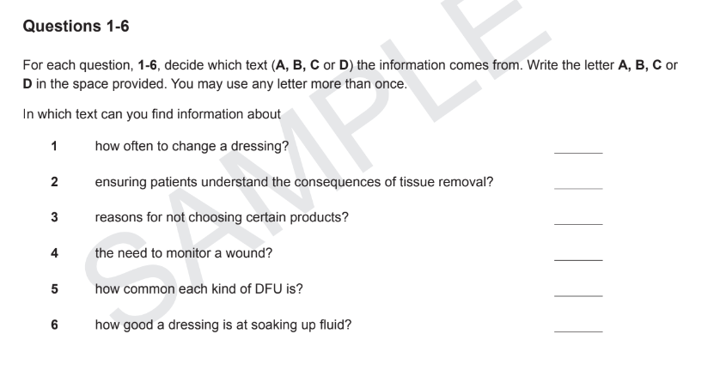

- B
- C

True/ False Statements:

Statement | T/F
It’s important to read every word from start to finish when looking for specific information. | - True  - False
Reading the headings first is a good strategy to help you understand the contents of the texts. | - True  - False
Your eyes should move in different directions over the page rather than just from left to right. | - True  - False
Checking the meaning of unknown words while searching for information is a good strategy. | - True  - False

Homework:

Find some examples of texts that you consult at work that are good examples of how textual features help to locate information.

We will share the examples you find next class and I will ask you to describe the textual features you have identified.

